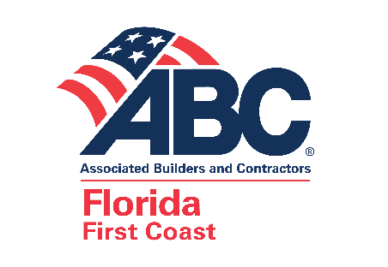

Essential Employee Letter - Generic

COMPANY is a Contractor performing Essential Services involving construction in in the State of Florida.

As local governments have passed Safer-At-Home or Shelter-In-Place Orders, all Orders designates “Contractors” as Essential Service.

You are an employee of COMPANY and are an essential worker whose job involves the Essential Services of a Contractor. Without you we cannot provide this Essential Services as a Contractor within the State of Florida.

In the event any travel restrictions are put in place related to the COVID-19 emergency, please accept
this letter as evidence that you are an essential worker.

Please feel free to contact me should you have any questions regarding this matter.

